Study Guide Unit 3 Name __________________________
DATA 110 Date ___________________________
Saidi
Exploring Relationships
- Plotly
- Scatterplots in ggplot
- Changing themes
- What to do with outliers
- Smoother and linear regression with and without confidence interval bands
- Understanding linear regression output
- Ggally for plotting pairs
- Performing multiple regression analysis and understanding regression plots
- Line and dot-and-line charts
- Bar charts, flipping coordinates
- Color Brewer

Knitting to HTML with interactive graphs
Later in this exploration, we will make plots interactive using the package “plotly”. If you plan to embed plotly, an interactive graphic package, in your code, you must have a plotly account in order for it to show up once you knit it to HTML.
Getting Started with Plotly for R

You have to sign in or sign up – it’s free. Once you have an account, you can knit your R Markdown file to HTML and your interactive plot will work.

Click here for the Rpubs Unit 3 document with the following notes.
Use data for this week’s work from here.

Unit 3 Correlation and Scatterplots

Rachel Saidi

May 25, 2019
knitr::opts_chunk$set(echo = TRUE)

Create a Scatterplot
In this example, look at US crime rates at the state level, in 2005, with rates per 100,000 population for crime types such as murder, robbery, and aggravated assault, as reported by the Census Bureau. There are 7 crime types in total. The dataset is clean to begin with.
library(readr)
library(ggplot2)
library(dplyr)
library(plotly)
##
## Attaching package: 'plotly'
crime <- read_csv('http://datasets.flowingdata.com/crimeRatesByState2005.csv')
## Parsed with column specification:
## cols(
## state = col_character(),
## murder = col_double(),
## forcible_rape = col_double(),
## robbery = col_double(),
## aggravated_assault = col_double(),
## burglary = col_double(),
## larceny_theft = col_double(),
## motor_vehicle_theft = col_double(),
## population = col_double()
## )
# source: U.S. Census Bureau and Nathan Yau

Check out the first few lines

state  <chr> | murder  <dbl> | forcible_rape  <dbl> | robbery  <dbl> | aggravated_assault  <dbl> | burglary  <dbl> | larceny_theft  <dbl>
United States | 5.6 | 31.7 | 140.7 | 291.1 | 726.7 | 2286.3
Alabama | 8.2 | 34.3 | 141.4 | 247.8 | 953.8 | 2650.0
Alaska | 4.8 | 81.1 | 80.9 | 465.1 | 622.5 | 2599.1
Arizona | 7.5 | 33.8 | 144.4 | 327.4 | 948.4 | 2965.2
Arkansas | 6.7 | 42.9 | 91.1 | 386.8 | 1084.6 | 2711.2
California | 6.9 | 26.0 | 176.1 | 317.3 | 693.3 | 1916.5
6 rows | 1-7 of 9 columns

Notice
The data has a column for the state and then the rest are rates for various crimes. Now make a quick scatterplot.

Map variables in the data onto the X and Y axes
# map values in data to X and Y axes
ggplot(crime, aes(murder, burglary))
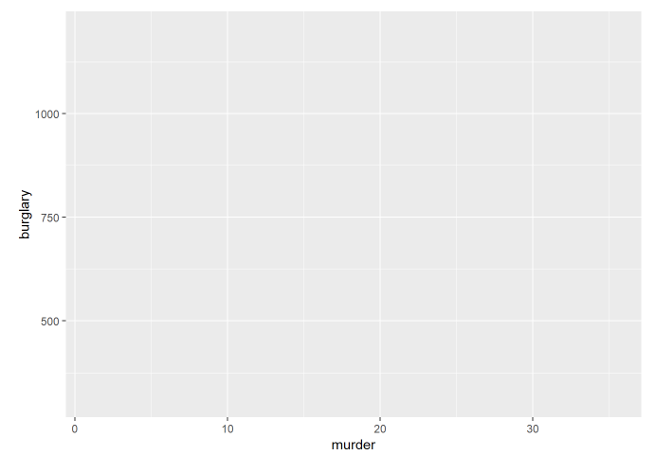
The brackets after the ggplot function define the data frame to be used, followed by the aes mapping of variables in the data to the chart’s X and Y axes.

Change the axes labels and theme
The default gray theme of ggplot2 has a rather academic look. See here and here for how to use the theme option to customize individual elements of a chart. Use one of the ggplot2 built-in themes, and then customize the fonts.
# Change the theme
ggplot(crime, aes(x = murder, y = burglary)) +
xlab("Murder rates in each state per 100,000") +
ylab("Burglary rates in each state per 100,000") +
theme_minimal(base_size = 12)
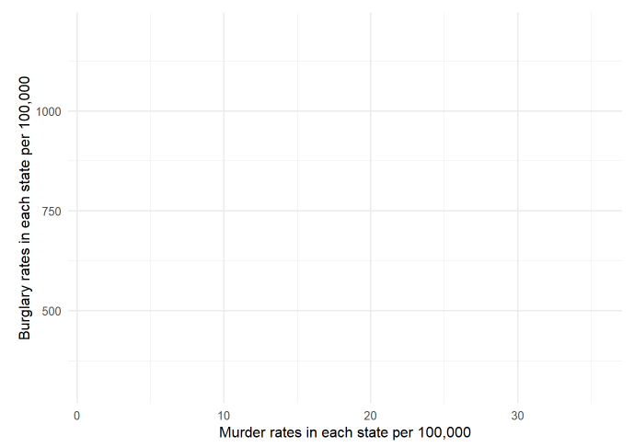
p1 <- ggplot(crime, aes(x = murder, y = burglary)) +
xlab("Murder rates in each state per 100,000") +
ylab("Burglary rates in each state per 100,000") +
theme_minimal(base_size = 12)
p1 + geom_point()
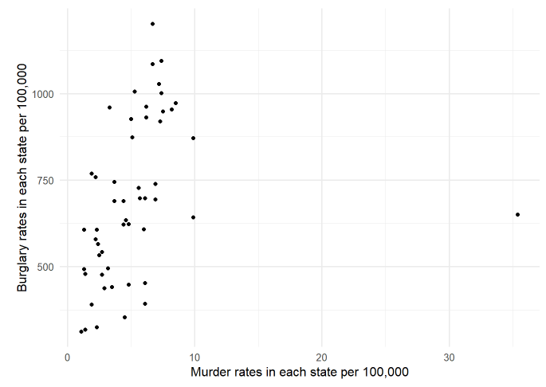

What is going on?
The one point off to the right represents Washington, D.C., which had a much higher murder rate of 35.4. The states with the next highest murder rate at that time were Louisiana and Maryland at 9.9 per 100,000.
Remove D.C. and US averages and replot:
crime2 <- crime[crime$state != "District of Columbia",]
crime2 <- crime2[crime2$state != "United States",]
p2 <- ggplot(crime2, aes(x = murder, y = burglary)) +
xlab("Murder rates in each state per 100,000") +
ylab("Burglary rates in each state per 100,000") +
theme_minimal(base_size = 12)
p2 + geom_point()
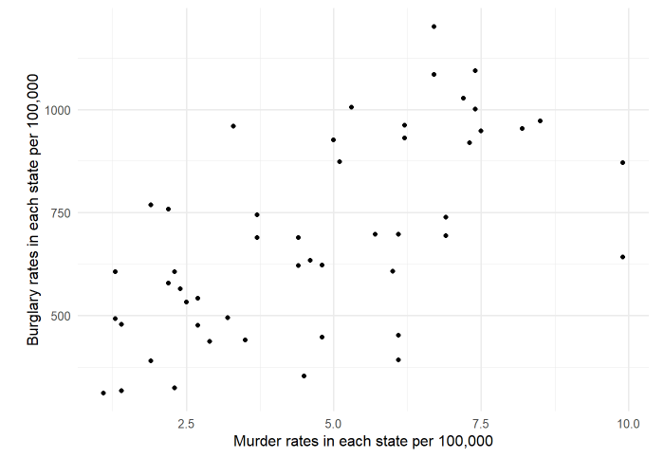

Now the scatterplot appears to show a correlation
Fix the axes to start at 0.
p3 <- p2 + xlim(0,10) + ylim(0,1200)
p3 + geom_point()
## Warning: Removed 1 rows containing missing values (geom_point).
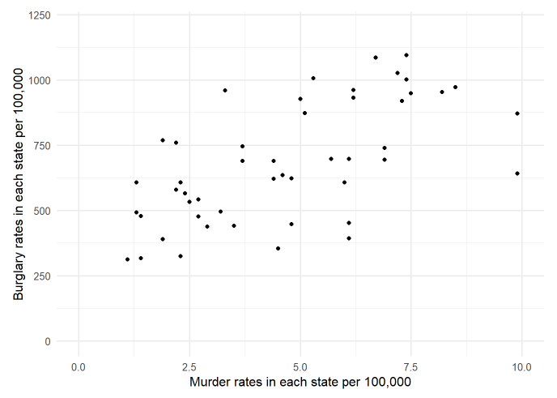

Add a smoother in red with a confidence interval
p4 <- p3 + geom_point() + geom_smooth(color = "red")
p4
## `geom_smooth()` using method = 'loess' and formula 'y ~ x'
## Warning: Removed 1 rows containing non-finite values (stat_smooth).
## Warning: Removed 1 rows containing missing values (geom_point).
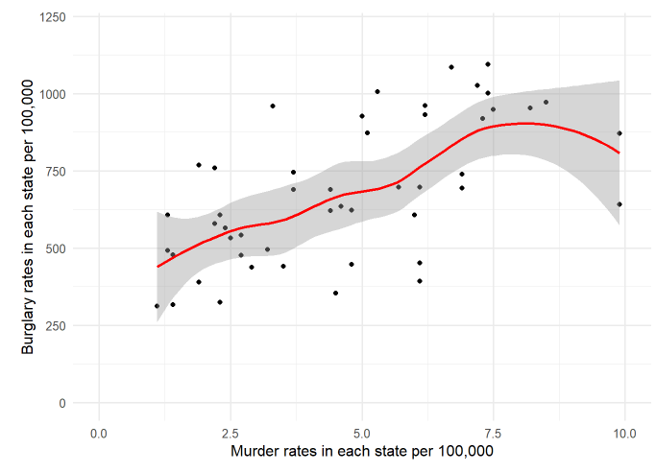

Add a linear regression with confidence interval
p5 <- p3 + geom_point() + geom_smooth(method='lm',formula=y~x)
p5
## Warning: Removed 1 rows containing non-finite values (stat_smooth).
## Warning: Removed 1 rows containing missing values (geom_point).
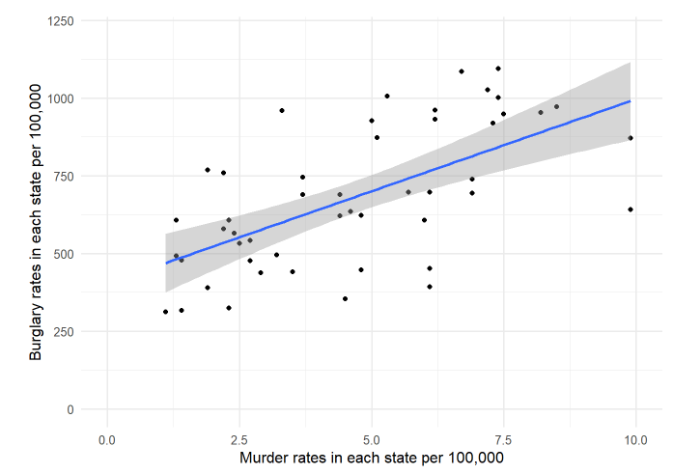

Add a title, make the line dashed, and remove the confidence interval
The command se = FALSE takes away the CI band
p6 <- p3 + geom_point() + geom_smooth(method='lm',formula=y~x, se = FALSE, linetype= "dotdash", size = 0.3) +
ggtitle("MURDERS VERSUS BURGLARIES IN THE U.S.")
p6
## Warning: Removed 1 rows containing non-finite values (stat_smooth).
## Warning: Removed 1 rows containing missing values (geom_point).
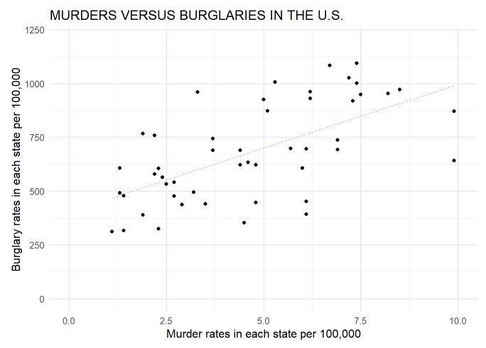

What is the linear equation of that linear regression model?
In the form, y=mx + b, we use the command, lm(y~x), meaning, fit the predictor variable x into the model to predict y. Look at the values of (Intercept) and murder. The column, Estimate gives the value you need in your linear model. The column for Pr(>|t|) describes whether the predictor is useful to the model. The more asterisks, the more the variable contributes to the model.
cor(crime2$burglary, crime2$murder)
## [1] 0.6231757
fit1 <- lm(burglary ~ murder, data = crime2)
summary(fit1)
##
## Call:
## lm(formula = burglary ~ murder, data = crime2)
##
## Residuals:
## Min 1Q Median 3Q Max
## -385.38 -132.23 2.97 138.78 386.32
##
## Coefficients:
## Estimate Std. Error t value Pr(>|t|)
## (Intercept) 398.26 59.28 6.718 1.99e-08 ***
## murder 62.17 11.26 5.521 1.34e-06 ***
## ---
## Signif. codes: 0 '***' 0.001 '**' 0.01 '*' 0.05 '.' 0.1 ' ' 1
##
## Residual standard error: 186.5 on 48 degrees of freedom
## Multiple R-squared: 0.3883, Adjusted R-squared: 0.3756
## F-statistic: 30.48 on 1 and 48 DF, p-value: 1.342e-06

What does the output mean?
The model has the equation: burglary = 62.17(murder) + 398.26
The slope may be interpreted in the following: For each additional murder per 100,000, there is a predicted increase of 62.17 burglaries.
The p-values on the right both have 3 asterisks so they suggest the model is meaningful, but we also need to look at the Adjusted R-Squared value. It states that about 38% of the variation in the observations may be explained by the model. In other words, 62% of the variation in the data is likely not explained by this model.

What about more variables?
Can a model with more predictors also be used? What would we be trying to predict?

Is there an easier way to compare multiple variables using a scatterplot matrix?
Check out the pairwise comparisons with density curves and correlation output
library(GGally)
ggpairs(crime2, columns = 2:8)
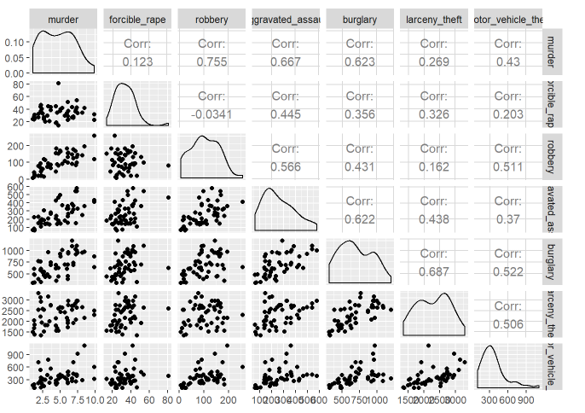
Robbery appears to be correlated with murder, burglary to larceny_theft and aggravated_assault, and burglary seems correlated with forcible_rate and larceny_theft.
Some of the strongest correlations are with burglary/larceny_theft and burglary/aggravated_assault

Now try to make a multiple regression model.
With multiple regression, there are several strategies for comparing variable inputs into a model. I will show you backward elimination. In backward elimination, start with all possible predictor variables with your response variable. In this case, we will use: burglary forcible_rape aggravated_assault larceny_theft motor_vehicle_theft Perform a model fit with all predictors.
- Look at the p-value for each variable - if it is relatively small ( < 0.10), then it is likely contributing to the model.
- Check out the residual plots. A good model will have a relatively straight horizontal red line across the scatterplot between residuals plotted with fitted values (see below for a good residuals plot). You can also look at the other plots (Normal QQ, Scale-Location, and Residuals vs Leverage), but for now we will focus on the residual vs. fitted plot. The more curved the red line, the more likely that a better model exists.
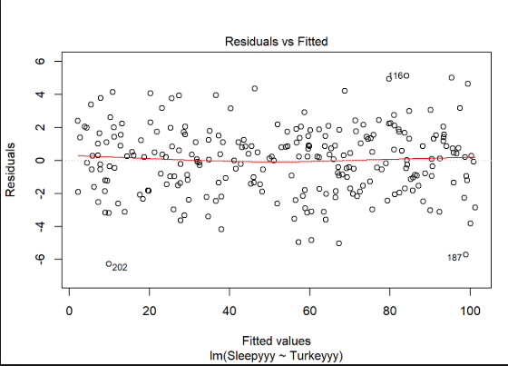

- Look at the output for the Adjusted R-Squared value at the bottom of the output. The interpretation is:
.% (from the adjusted r-squared value) of the variation in the observations may be explained by this model. The higher the adjusted R-squared value, the better the model. We use the adjusted R-squared value because it compensates for more predictors mathematically increasing the normal R-squared value.
fit2 <- lm(murder ~ burglary + forcible_rape + aggravated_assault + larceny_theft + motor_vehicle_theft, data = crime2)
summary(fit2)
##
## Call:
## lm(formula = murder ~ burglary + forcible_rape + aggravated_assault +
## larceny_theft + motor_vehicle_theft, data = crime2)
##
## Residuals:
## Min 1Q Median 3Q Max
## -3.0273 -0.8949 -0.1242 0.6644 3.3027
##
## Coefficients:
## Estimate Std. Error t value Pr(>|t|)
## (Intercept) 3.0252038 1.0642566 2.843 0.006761 **
## burglary 0.0050527 0.0014907 3.389 0.001488 **
## forcible_rape -0.0461137 0.0216312 -2.132 0.038644 *
## aggravated_assault 0.0094150 0.0022044 4.271 0.000102 ***
## larceny_theft -0.0015024 0.0006003 -2.503 0.016104 *
## motor_vehicle_theft 0.0020733 0.0012653 1.639 0.108440
## ---
## Signif. codes: 0 '***' 0.001 '**' 0.01 '*' 0.05 '.' 0.1 ' ' 1
##
## Residual standard error: 1.522 on 44 degrees of freedom
## Multiple R-squared: 0.6287, Adjusted R-squared: 0.5866
## F-statistic: 14.9 on 5 and 44 DF, p-value: 1.49e-08
plot(fit2)
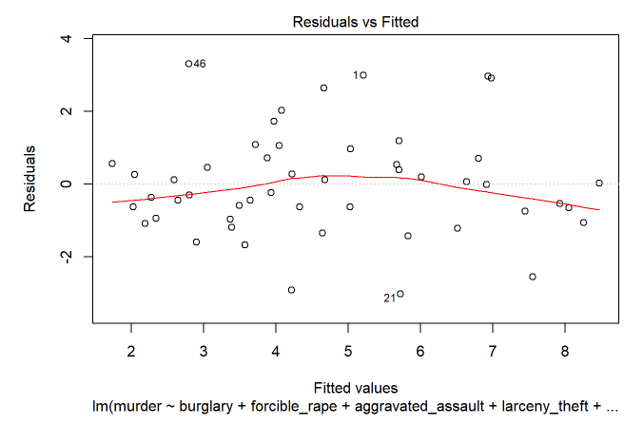

You are looking for a straight horizontal red line going through at residuals = 0. In this case, the line is curved and observations at 1, 21, and 46 are identified at pulling the line away from being straight.
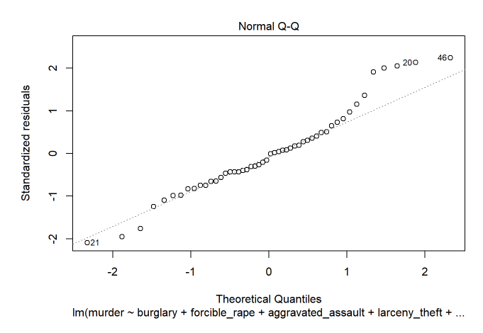
The Normal QQ line is another measure of normal distribution. When observations fall along the diagonal line, the distribution is normal. The further away and the more that are far away indicates the distribution is not normal. #20, #21, and #46 are identified as skewing the distribution.
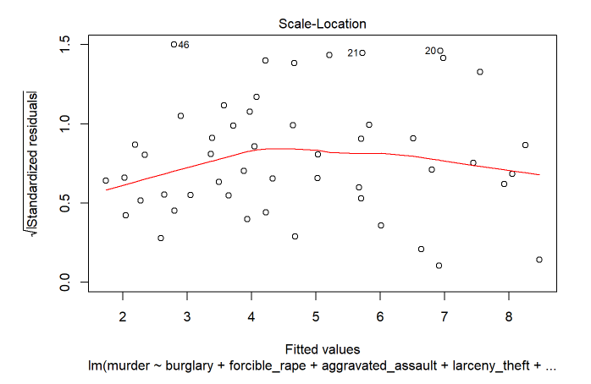
Scale-Location plots fitted (predicted) values to the square root of the standardized residuals. Again, you are looking for a straight red line in a hypothetical situation, indicating that residuals are randomly spread, with no indicated pattern. Once again, #20, 21, and 46 are identified as skewing results.
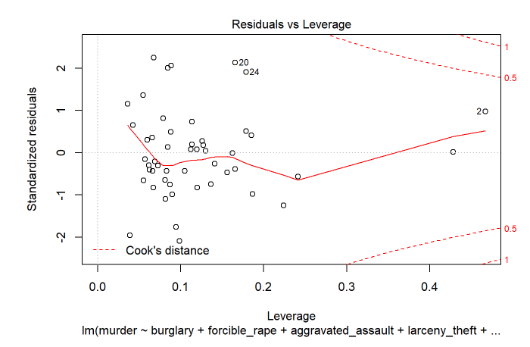
Finally, Leverage is measured by Cook’s distance. Unlike the other plots, this time patterns are not relevant. Watch out for outlying values at the upper right corner or at the lower right corner. Those spots are the places where cases can be influential against a regression line. Look for cases outside of a dashed line, Cook’s distance. In this case, only #2 is identified as having large leverage with it’s high Cook’s distance.
You can decide what to do with observations such as #2, 20, 21, and 46. You may eliminate one at a time and re-run the code to see if that improves the plots. Although I will go through other iterations of model plots, I will not show them again in these class notes (though you CAN find all plots on the rpubs version of these notes).
For more information on what these multiple regression plots mean, here is a good resource:
https://data.library.virginia.edu/diagnostic-plots/

What are we really trying to predict?
If we are trying to predict murder rates, then we can see if any of the predictor variables contribute to this model. Note the adjusted R-squared value is 58.66% The only variable that does not appear to be as significant as the others is motor_vehicle_theft. So drop that and re-run the model.
fit3 <- lm(murder ~ burglary + forcible_rape + aggravated_assault + larceny_theft, data = crime2)
summary(fit3)
##
## Call:
## lm(formula = murder ~ burglary + forcible_rape + aggravated_assault +
## larceny_theft, data = crime2)
##
## Residuals:
## Min 1Q Median 3Q Max
## -3.1805 -1.0081 -0.3100 0.8769 3.4506
##
## Coefficients:
## Estimate Std. Error t value Pr(>|t|)
## (Intercept) 2.8415937 1.0779713 2.636 0.011468 *
## burglary 0.0055794 0.0014826 3.763 0.000483 ***
## forcible_rape -0.0471186 0.0220236 -2.139 0.037858 *
## aggravated_assault 0.0096735 0.0022395 4.320 8.51e-05 ***
## larceny_theft -0.0012679 0.0005938 -2.135 0.038211 *
## ---
## Signif. codes: 0 '***' 0.001 '**' 0.01 '*' 0.05 '.' 0.1 ' ' 1
##
## Residual standard error: 1.55 on 45 degrees of freedom
## Multiple R-squared: 0.6061, Adjusted R-squared: 0.5711
## F-statistic: 17.31 on 4 and 45 DF, p-value: 1.153e-08
plot(fit3)
The residuals plot looks worse once we drop motor_vehicle_theft, AND the adjusted R-squared value dropped to 57.11%. Maybe one last exploration is to change what we are predicting

Change the model to predict for burglary instead of murder
fit4 <- lm(burglary ~ murder + forcible_rape + aggravated_assault + larceny_theft + motor_vehicle_theft, data = crime2)
summary(fit4)
##
## Call:
## lm(formula = burglary ~ murder + forcible_rape + aggravated_assault +
## larceny_theft + motor_vehicle_theft, data = crime2)
##
## Residuals:
## Min 1Q Median 3Q Max
## -271.30 -79.31 -7.40 94.15 387.49
##
## Coefficients:
## Estimate Std. Error t value Pr(>|t|)
## (Intercept) -138.27831 102.16469 -1.353 0.18281
## murder 40.97562 12.08935 3.389 0.00149 **
## forcible_rape 2.19565 2.01915 1.087 0.28278
## aggravated_assault 0.12375 0.23536 0.526 0.60168
## larceny_theft 0.22136 0.04716 4.693 2.64e-05 ***
## motor_vehicle_theft 0.06020 0.11702 0.514 0.60955
## ---
## Signif. codes: 0 '***' 0.001 '**' 0.01 '*' 0.05 '.' 0.1 ' ' 1
##
## Residual standard error: 137 on 44 degrees of freedom
## Multiple R-squared: 0.6975, Adjusted R-squared: 0.6631
## F-statistic: 20.29 on 5 and 44 DF, p-value: 1.907e-10
plot(fit4)

Interesting!!
The adjusted R-squared went up to 66.31%. The residuals plot looks worse, but we can drop all predictors that are no longer significant. We are left with murder and larceny_theft. Run that model.
fit5 <- lm(burglary ~ murder+ larceny_theft, data = crime2)
summary(fit5)
##
## Call:
## lm(formula = burglary ~ murder + larceny_theft, data = crime2)
##
## Residuals:
## Min 1Q Median 3Q Max
## -297.93 -101.83 2.21 98.54 352.09
##
## Coefficients:
## Estimate Std. Error t value Pr(>|t|)
## (Intercept) -117.85224 90.22758 -1.306 0.198
## murder 47.15078 8.55929 5.509 1.48e-06 ***
## larceny_theft 0.25566 0.03919 6.524 4.31e-08 ***
## ---
## Signif. codes: 0 '***' 0.001 '**' 0.01 '*' 0.05 '.' 0.1 ' ' 1
##
## Residual standard error: 136.6 on 47 degrees of freedom
## Multiple R-squared: 0.679, Adjusted R-squared: 0.6654
## F-statistic: 49.72 on 2 and 47 DF, p-value: 2.522e-12
plot(fit5)

The model looks good. The residuals plot shows observations 20, 33, and 46 have an effect on the residuals plot, and 33 appears to have high leverage with Cooks distance.
Maryland is 20 North Carolina is 33 Virginia is 46
It is interesting that they are all very close in proximity.

Back to simply murders and burglaries - bring in the state’s population
p3 +
geom_point(mapping = aes(murder, burglary, size = population), color = "red") + xlim(0,10) + ylim(0,1200) +
ggtitle("MURDERS VERSUS BURGLARIES IN THE U.S.", subtitle = "Sizes of circles are proportional to state populations")
## Scale for 'x' is already present. Adding another scale for 'x', which
## will replace the existing scale.
## Scale for 'y' is already present. Adding another scale for 'y', which
## will replace the existing scale.
## Warning: Removed 1 rows containing missing values (geom_point).
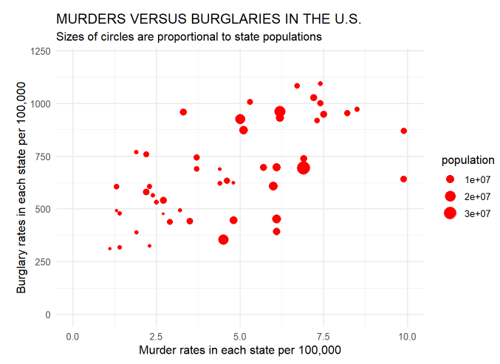

Finally, add some interactivity to the plot with plotly
p <- ggplot(crime2, aes(x = murder, y = burglary, size = population, text = paste("state:", state))) + theme_minimal(base_size = 12) +
geom_point(alpha = 0.5, color = "red") + xlim(0,10) + ylim(0,1200) +
ggtitle("MURDERS VERSUS BURGLARIES IN THE U.S.", subtitle = "Sizes of circles are proportional to state populations")
p <- ggplotly(p)
p

Using plotly, when you mouse-over the points, you get a box with information about each observation.

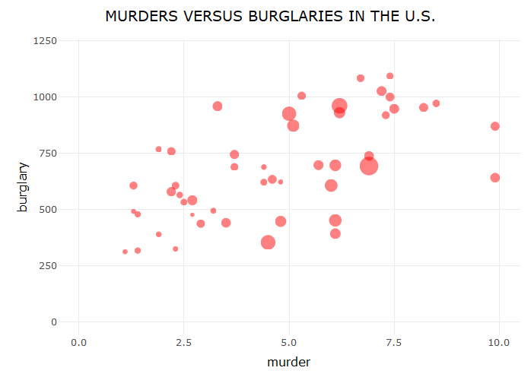

Make a series of charts from food stamps data
Now we will explore a series of other geom functions using the food stamps data.

Load the data, map variables onto the X and Y axes, and save chart template
# load data
food_stamps <- read_csv("week9/food_stamps.csv")
## Parsed with column specification:
## cols(
## year = col_double(),
## participants = col_double(),
## costs = col_double()
## )
# save basic chart template
food_stamps_chart <- ggplot(food_stamps, aes(x = year, y = participants)) +
xlab("Year") +
ylab("Participants (millions)") +
theme_minimal(base_size = 14)
food_stamps_chart

Make a line chart
food_stamps_chart +
geom_line()
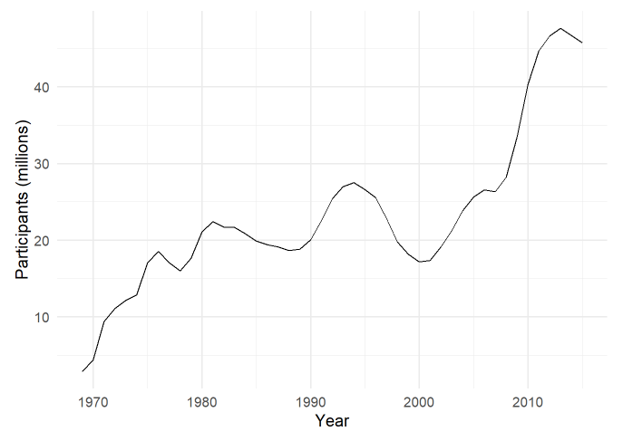

Customize the line, and add a title
food_stamps_chart +
geom_line(size = 1.5, color = "red") +
ggtitle("Line chart")
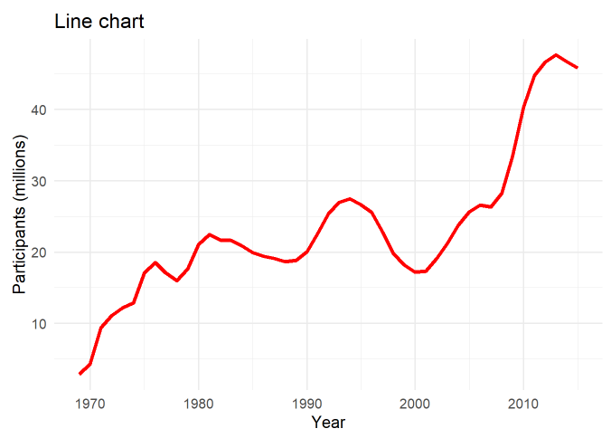

Add a second layer to make a dot-and-line chart
food_stamps_chart +
geom_line() +
geom_point() +
ggtitle("Dot-and-line chart")
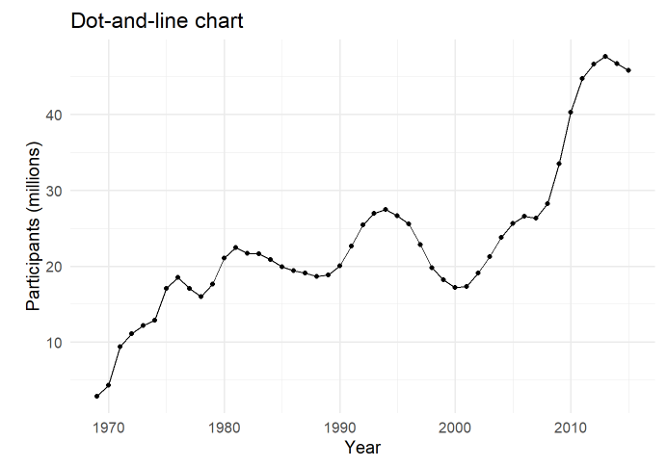

Make a column chart, then flip its coordinates to make a bar chart
# Make a column chart
food_stamps_chart +
geom_bar(stat = "identity") +
ggtitle("Column chart") +
theme(panel.grid.major.x = element_blank(),
panel.grid.minor.x = element_blank())
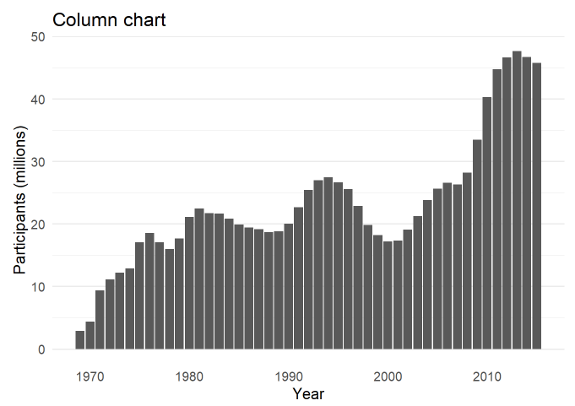
geom_bar works a little differently to the geoms we have considered previously. If you have not mapped data values to the Y axis with aes, its default behavior is to set the heights of the bars by counting the number of records for values along the X axis. If you have mapped a variable to the Y axis, and want the heights of the bars to represent values in the data, use you must use stat=“identity”.

coord_flip switches the X and Y axes.
# Make a bar chart
food_stamps_chart +
geom_bar(stat = "identity") +
ggtitle("Bar chart") +
theme(panel.grid.major.x = element_blank(),
panel.grid.minor.x = element_blank()) +
coord_flip()
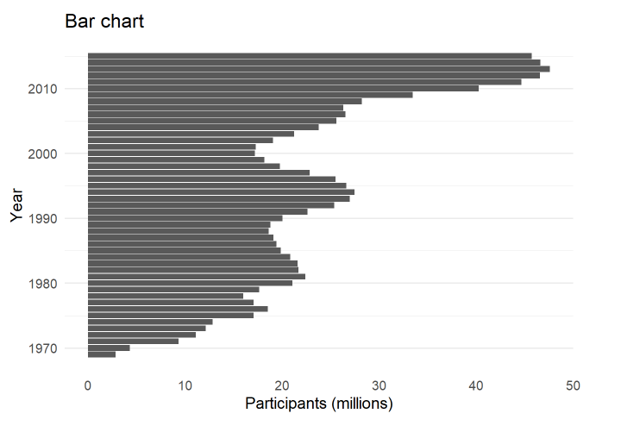

The difference between color and fill
For some geoms, notably geom_bar, you can set color for their outline as well as the interior of the shape.
When setting colors, color refers to the outline, fill to the interior of the shape.
# set color and fill
food_stamps_chart +
geom_bar(stat = "identity", color = "#888888", fill = "#CCCCCC", alpha = 0.5) +
ggtitle("Column chart")
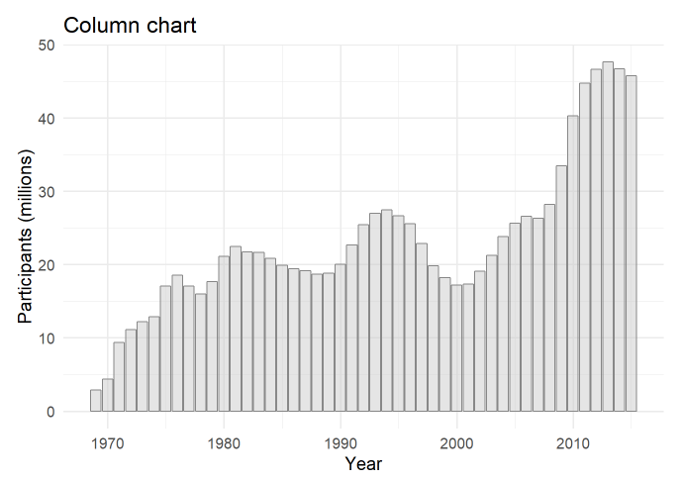

Map color to the values of a continuous variable
# fill the bars according to values for the cost of the program
food_stamps_chart +
geom_bar(stat = "identity", color= "white", aes(fill = costs))
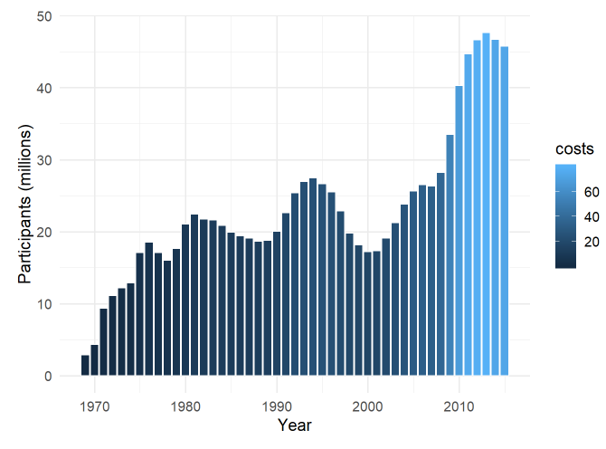
This code uses an aes mapping to color the bars according values for the costs of the program, in billions of dollars. ggplot2 recognizes that costs is a continuous variable, but its default sequential scheme applies more intense blues to lower values, which is counterintuitive.

Use a ColorBrewer sequential color palette
# use a colorbrewer sequential palette
food_stamps_chart +
geom_bar(stat = "identity", color = "#888888", aes(fill = costs)) +
scale_fill_distiller(name = "Cost\n($ billion)", palette = "Reds", direction = 1)
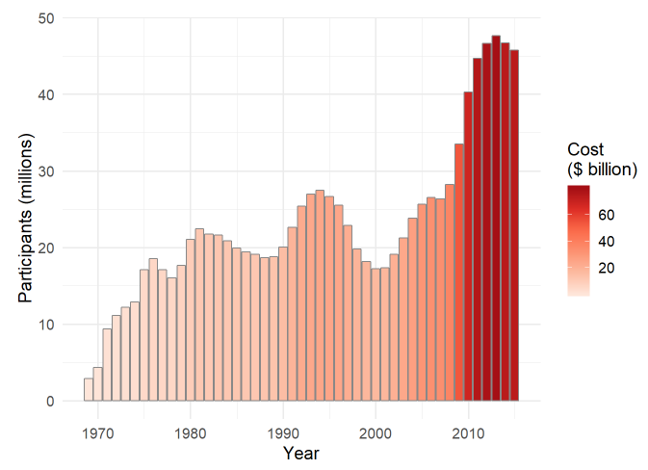
scale_fill_distiller (and scale_color_distiller) work like scale_color_brewer, but set color gradients for ColorBrewer’s sequential and diverging color palettes.
Direction = 1 ensures that larger numbers are mapped to more intense colors (direction = -1 reverses the color mapping).
Notice also the in the title for the legend. This introduces a new line.

Control the position of the legend
This code uses the theme function to moves the legend from its default position to the right of the chart to use some empty space on the chart itself.
food_stamps_chart +
geom_bar(stat="identity", color = "#888888", aes(fill=costs)) +
scale_fill_distiller(name = "Cost\n($ billion)", palette = "Reds", direction = 1) +
theme(legend.position=c(0.15,0.8))
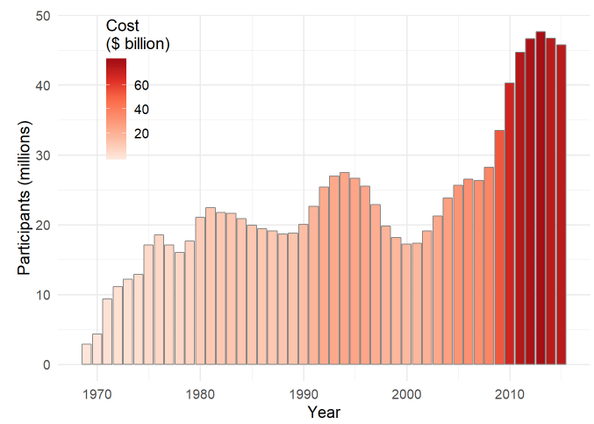
The coordinates for the legend are given as a list: The first number sets the horizontal position, from left to right, on a scale from 0 to 1; the second number sets the vertical position, from bottom to top, again on a scale from 0 to 1.

Unit 3 Homework Assignment

(Worth up to 10 points for each chart) Use dplyr and ggplot2 to process data and draw these two charts (shown below) from the nations dataset:
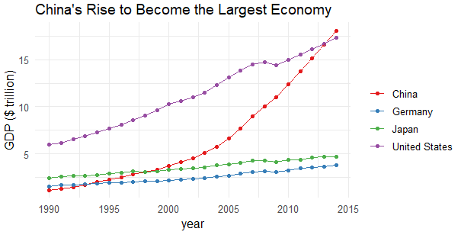
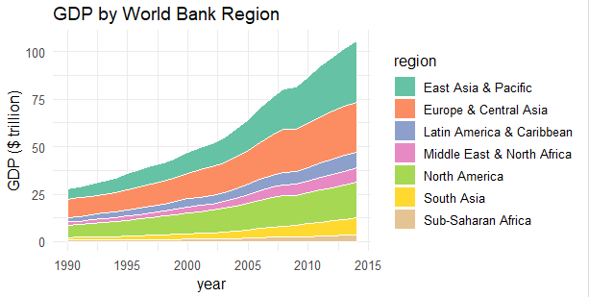
Details
- For both charts, you will first need to create a new variable in the data, using mutate from dplyr, giving the GDP of each country in trillions of dollars, by multiplying gdp_percap by population and dividing by a trillion.
- When drawing both charts with ggplot2 you should also manually set the X axis tick mark labels (otherwise the default will be to include a label for 2015, for which there is no data.)
- For the first chart, you will need to filter the data with dplyr for the four desired countries. When making the chart with ggplot2 you will need to add both geom_point and geom_line layers, and use the Set1 ColorBrewer palette using: scale_color_brewer(palette = "Set1").
- For the second chart, using dplyr you will need to group_by region and year, and then summarize on your mutated value for gdp_percap using
summarise(sum = sum(gdp_percap, na.rm = TRUE)). (There will be null values, or NAs, in this data, so you will need to use na.rm = TRUE).
- Each region’s area will be generated by the command geom_area ()
- When drawing the chart with ggplot2, you will need to use the Set2 ColorBrewer palette using scale_fill_brewer(palette = "Set2")
- Think about the difference between fill and color when making the chart, and where the above fill command needs to go in order for the regions to fill with the different colors when making the chart, and put a very thin white line around each area.
Save each chart on a Word document to submit in your Unit 3 Assignment Dropbox. Both submissions are due at 11:59pm on August 5th.

